**Project 1 - Identifying and Recommending Best Restaurants**

**To:** Head of Marketing & Product Development  
**From:** Thapelo Masebe, Jnr Data Scientist  
**Date:** August 07, 2025  
**Subject:** Analysis of Restaurant Data to Identify "Star" Performers for B-to-C Portal Revamp

**1. Executive Summary**

This report analyses data from 9,542 restaurants across various cities to identify the key metrics that define a top-performing or "star" restaurant. The objective is to inform the development of an intelligent recommendation engine for our B-to-C portal. The analysis reveals that **customer engagement (measured by the number of 'Votes') is a significantly stronger indicator of high ratings than price or service offerings.** The most successful restaurants are those that generate the most reviews. We recommend that the portal's new recommendation algorithm heavily feature restaurants with high engagement to build user trust and maximize satisfaction.

**2. Problem Statement**

As a restaurant consolidator looking to revamp our B-to-C portal with intelligent automation, we are in search of the key metrics that identify and define a successful restaurant. This analysis of the provided dataset is crucial to understanding the underlying data behaviour, which will enable the effective implementation of a new recommendation model.

**3. Data Preparation**

The analysis was conducted on a single dataset containing restaurant information. The initial inspection revealed a clean dataset with no significant missing values, though it contained a small number of duplicate entries which were removed. Column names were standardized for clarity. The final, cleaned dataset of 9,542 unique restaurants served as the basis for this analysis.

**4. Exploratory Data Analysis (EDA) & Key Findings**

The cleaned data was visualized in an interactive Tableau dashboard to explore the key factors influencing restaurant success. The dashboard provides a comprehensive overview of the market and allows for dynamic filtering across cities, cuisines, and price points.

*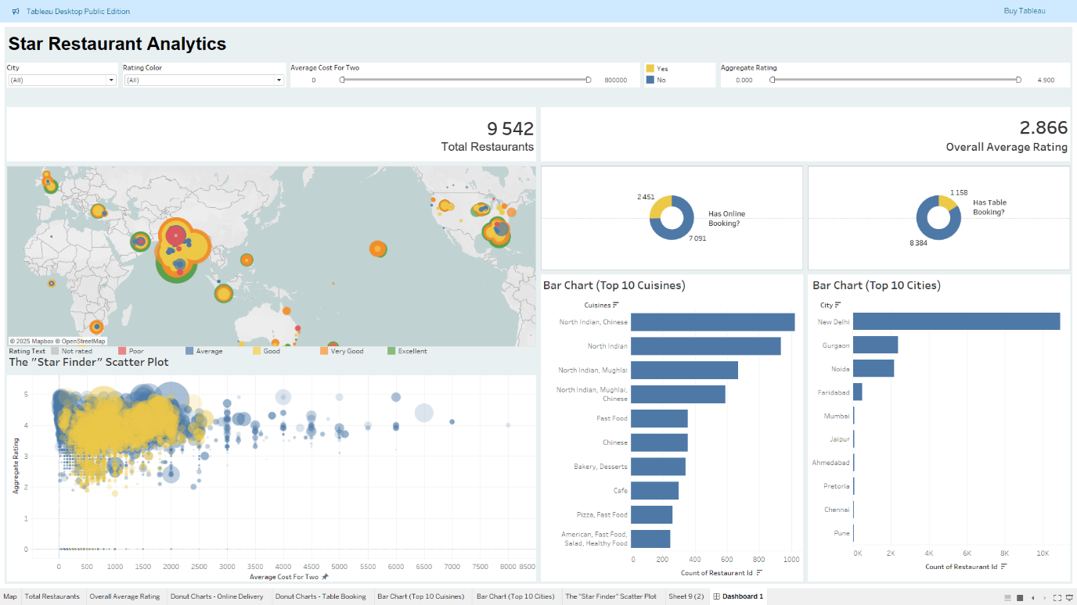***Figure 1: Star Restaurant Analytics Interactive Dashboard**

**Key insights derived from the dashboard include:**

* **Insight 1: Customer Engagement is the True Measure of a "Star" Restaurant**  
  The "Star Finder" scatter plot is the most revealing chart. It shows that the largest circles (representing the most "Votes") are heavily concentrated in the high-rating tiers (3.5 to 5.0), regardless of their position on the cost axis. This strongly indicates that **customer engagement is the primary driver of a restaurant's reputation and success.** Highly-rated restaurants are not necessarily the most expensive, but they are consistently the most talked about.
* **Insight 2: Geographic Market Saturation and Opportunity**  
  The map and "Top 10 Cities" bar chart clearly show that cities like **New Delhi** are highly saturated markets with a very high density of restaurants. While this indicates a large customer base, it also signals intense competition. In contrast, other major cities show fewer restaurant listings, which could represent untapped market opportunities for business development and partnership focus.
* **Insight 3: Service Offerings are Standard, Not Differentiators**  
  The donut charts show that a significant majority of restaurants **(74.6%) offer Online Delivery**, while a much smaller portion **(12.2%) offer Table Booking**. While online delivery is now a standard expectation, the relative scarcity of table booking could be a niche feature to highlight for users seeking that specific convenience.
* **Insight 4: Dominance of Core Cuisines**  
  The "Top 10 Cuisines" bar chart demonstrates that across all major cities, **North Indian and Chinese cuisines are overwhelmingly the most common.** This suggests they are "safe bets" for broad customer appeal, while other cuisines represent more specialized, niche markets that could be targeted for specific user segments.

**5. Actionable Recommendations**

Based on this analysis, we recommend the following strategies for the B-to-C portal revamp:

1. **Prioritize Engagement in the Recommendation Algorithm:** The core logic of the new recommendation engine should heavily weight the **number of votes**. Restaurants with high votes and high ratings should be featured prominently as "Top Picks" or "Trending," as this is the most reliable indicator of customer-proven quality.
2. **Use Filters to Empower Users:** The portal's user interface should feature prominent and easy-to-use filters for City, Cuisine, Price Range, Online Delivery, and Table Booking. This allows users to quickly find restaurants that match their specific needs.
3. **Target Business Development Geographically:** Use the interactive map to identify cities with lower restaurant density but potentially high user traffic. These areas represent strategic opportunities to expand our restaurant partnerships and gain a competitive advantage.